REAL TIME HAND GESTURES RECOGNITION BASED ON FINGER POINT TRACKING

A project dissertation submitted to Bharathidasan University

in partial fulfillment of the requirements for the award of the Degree of

MASTER OF SCIENCE IN DATA SCIENCE

Submitted by

DIVYAA LAKSHMI A S (205229109)

Guided by

Ms. INDRA DEVI D., M.E.
Guest Faculty


DEPARTMENT OF DATA SCIENCE
BISHOP HEBER COLLEGE (AUTONOMOUS)
(Nationally Reaccredited at the „A‟ Grade by NAAC with the CGPA of 3.58 out of 4)

(Recognized by UGC as “College with Potential for Excellence”)
(Affiliated to Bharathidasan University)

TIRUCHIRAPPALLI 620017

MAY 2022
DECLARATION

I hereby declare that the project work presented is originally done by me under the guidance of

Ms. Indra Devi D, M.E, Department of Data Science, Bishop Heber College (Autonomous), Tiruchirappalli 620017, and has not been included in any other thesis/project submitted for any other degree.

Name of the Candidate | : | DIVYAA LAKSHMI A S
Register Number | : | 205229109
Batch | : | 2020-2022

Signature of the Candidate

DEPARTMENT OF DATA SCIENCE
BISHOP HEBER COLLEGE (AUTONOMOUS)
(Nationally Reaccredited at the „A‟ Grade by NAAC with the CGPA of 3.58 out of 4)
(Recognized by UGC as “College with Potential for Excellence”)

(Affiliated to Bharathidasan University)

TIRUCHIRAPPALLI 620017

Date:

Course Title: Project Course Code: P19DS4PJ

BONAFIDE CERTIFICATE

This is to certify that the project work titled “REAL TIME HAND GESTURES

RECOGNITION BASED IN FINGER POINT TRACKING” is a bonafide record of the

project work done by DIVYAA LAKSHMI A S, 205229109, in partial fulfillment of the

requirements for the award of the degree of MASTER OF SCIENCE IN DATA SCIENCE

during the period 2020 - 2022.

The Viva-Voce examination for the candidate DIVYAA LAKSHMI A S, 205229109, was held on _________________.

Signature of the HOD

Examiners:

1.

Signature of the Guide

2.

ACKNOWLEDGEMENTS

I take this opportunity to express my thanks to Dr. D. PAUL DHAYABARAN., M.Sc., PGDCA., M.Phil., Ph.D., Principal Bishop Heber College, Trichy, for providing me with sufficient facilities which contributed to the successful completion of the project

I like to express my sincere gratitude and deep thanks to Dr. K.RAJKUMAR M.Sc., M.Phil., Ph.D., Head of the Department of Data Science and who has been a source of encouragement and moral strength throughout my study period.

This project would not have been possible without the motivation and guidance of my Internal guide MS. INDRA DEVI D., M.E., Guest Faculty and Department of Data Science. I whole heartedly thank her because this is possible only because of patience support and ready guidance. I wish to thank her for being kind and considerate in all respects towards me right from the beginning. She is the backbone of my project and her encouragement and moral support to finish this project

I extremely thankful to my family members and my dear friends who helped me lot in the completion of the project.

A.S. DIVYAA LAKSHMI

Document Information

Analyzed document | 205229109_DIVYA.pdf (D138087390)
Submitted | 2022-05-26T06:10:00.0000000
Submitted by | Librarian
Submitter email | librarypds@bhc.edu.in
Similarity | 13%
Analysis address | librarypds.bhc@analysis.urkund.com

Sources included in the report


URL: https://techtutorialsx.com/2021/04/10/python-hand-landmark-estimation/ | 8
Fetched: 2021 06-02T10:12:32.7700000 | 8

ABSTRACT

Communication is easy for many of us, but it is difficult for others, such as the deaf and dumb. It's a barrier that's stifling their potential and lowering their efficiency; we can only communicate with such people if we know sign language, which is a structured kind of communication, or if there's an interpreter in the middle. Attempts to eliminate their obstacles to some extent by developing a Gesture Recognition Model using Convolutional Neural Networks (CNN) that can predict and convert dynamic hand movements. Even individuals unfamiliar with sign language will be able to understand what they have.

The data needed for categorization in the existing system is acquired using various sensors the most popular option in this domain is Data gloves or LEDs, but the use of external devices obstructs natural movement and the solution is not economically viable. So the proposed system incorporating the sign language into a model that accurately recognises gestures and translates the expected motion into text using deep learning Convolution Neural Networks.

MediaPipe is the recognition technique employed in this case. A Graph is the name given to the MediaPipe's perception pipeline. Take the case of Hands, for instance. We give a stream of photos as input, which are rendered with hand landmarks, and then develop a model to classify the sign and provide a label about the identified sign.

It is possible to recognize different English signs with an accuracy of 90%, in real time, and with a computer camera.

vi
 | TABLE OF CONTENTS
Chapter | Title | Page No
 | Abstract | vi
 | List of Figures | viii
 | List of Tables | ix
1 | Introduction | 1
1.1 | Motivation
1.2 | Existing Systems/Products and Solutions
1.3 | Product Needs and Proposed System
1.4 | Product Development Timeline
2 | Related Work and Solutions Review | 3
2.1 | Related Work 1
2.2 | Related Work 2
2.3 | Related Work 3
3 | Data Collection | 5
3.1 | Description of the Data
3.2 | Source and Methods of Collecting Data
4 | Preprocessing and Feature Selection | 6
4.1 | Overview of Preprocessing Methods
4.2 | Overview of Feature Selection Methods
5 | Model/Product Development | 8
5.1 | Model Architecture
5.2 | Algorithms Applied
5.3 | Training Overview
6 | Experimental Design and Evaluation | 11
6.1 | Experimental Design
6.2 | Experimental Evaluation
6.3 | Customer Evaluation and Feedback
7 | Model/Product Optimization | 15
7.1 | Overview of Model Tuning and Best Parameter Selection
7.2 | Model Tuning Process and Experiments
8 | Product Delivery and Deployment | 16
8.1 | User Manuals
8.2 | Delivery Schedule
9 | Conclusion | 18
9.1 | Summary
9.2 | Limitation and Future Work
 | References | 19
 | Appendix-A: Data Set | 20
 | Appendix-B: Source Code | 21
 | Appendix-C: Output Screenshots | 29

LIST OF FIGURES

Figure No. | Description | Page
3.1 | Hands Keypoints | 11
5.1 | Model Architecture | 14
6.2 | Model Accuracy | 19
6.3 | Model Loss | 20

viii
LIST OF TABLES

Table No. | Description | Page
6.1 | Classification report | 18
8.1 | Delivery Schedule | 23

ix
Chapter 1

INTRODUCTION

1.1 Motivation

A sign language system could help Deaf and hearing people communicate more effectively. The method of creating such a system utilising neural networks allows for the investigation and extension of networks between the deaf-dump community and the general public.

1.2 Existing Systems and Solutions

In Existing system, A various hand gestures were recognized with different methods by different researchers in which were implemented in different fields. vision-based methods, data glove-based methods, and soft computing methods such as Artificial Neural Networks, Fuzzy logic, Genetic Algorithms, and others were used to recognise diverse hand motions and others like PCA, Canonical Analysis, etc. And also video will be used as a dataset, convert a video into frame and each frame has some hand gesture then assign the corresponding signs to that frame. Apart from video some of them used a image dataset like different posture of each image after label the input image.BSL uses a two-handed finger- spelling system, compared to the one-handed system.

1.3 Product Needs and Proposed System

Hand gestures recognition is the process of converting a user's gestures and signs into text. It is beneficial to people who are unable to communicate with the general public. Using image processing techniques and neural networks, the motion is mapped to appropriate text in the training data, converting raw images/videos into text that can be read and comprehended.. The proposed system uses a dataset as a kepoint from 21 3D landmarks of a hand from just a single frame through media pipe. It would be a real-time system that would process live sign gestures utilising image processing. Then classifiers would be employed to distinguish between distinct signs, and the translated result would be text.

Requirements of tools and Libraries in Proposed System
- PyCharm

- Python programming

- MediaPipe

- KeyPointClassifier

- CV

1

1.4 Product Development and Timeline
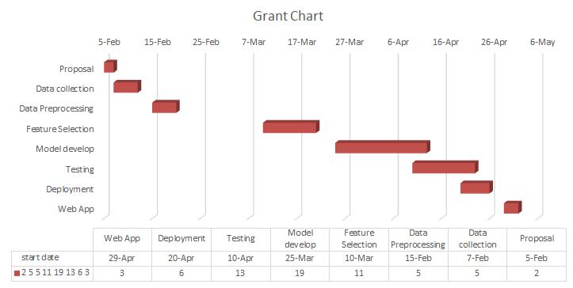

2

Chapter 2

RELATED WORK AND SOLUTIONS REVIEW

2.1 Related Work1

Naresh Kumar [1] introduced idea of feasible communication between hearing impaired and normal person with the help of machine learning approach. Instead of preprocessing techniques, like filtering and segmentation of hand patch images, they extract features from their dataset by discrete wavelet transform. Linear discriminant analysis reduces the dimension of the feature vector. On the basis of tenfold classification, both linear discriminant analysis (LDA) and support vector machine (SVM) are employed to recognise sign language symbols.. This work ensures the 97.3% accuracy on random sign symbolic dataset of gestural communication.. R.S. Sabeenian.et.al.[2] commented a system where any one Infront of camera can make the gestures and the system will interpret it for others in real time. This makes use of a deep neural network trained on a sign language dataset to guess what the sign is and display it on the screen. The prediction time is less than in prior systems that used a deep neural network framework to forward propagate images. Tulay Karayilan.et.al.[3] suggested a sign language recognition system employing Backpropagation Neural Network Algorithm. With two proposed classifiers, the neural network of this system took extracted image attributes as input and was trained using the backpropagation technique to determine which letter was the given letter with accuracy of 70% and 85%. Raw Features Classifier is the first classifier, and it employs 3072 features. The Histogram Characteristics Classifier, the second classifier, uses 512 features. The Backpropagation Algorithm is then used to train two classifiers. Finally, text is generated from the projected results obtained from classifiers.

2.2 Related Work2

Manisha et.al.[4] introduced the convolutional neural network (CNN) as a classifier for training and predicting Tamil sign language. The process is divided into two sections: the first is to train using the keras model, and the second is to skin segment the hand gestures in the region of interest. There are two phases in training the model: having a set of hand gestures images in the training set and testing set using the image, the model occurred the 100% accuracy in the white background and good lighting condition, 97.5 % in the low lighting condition. Swaraj

3
Dahibavkar.et.al.[5] commented on employing segmentation and skin colour detection to

recognise the Marathi sign to alphabets. The edge-based segmentation method is used for image

segmentation. While providing input to the camera, the signer should bear in mind that they

should wear non-skin coloured or dark coloured clothing, and the background should not be the

same as the skin colour. If these requirements are met, the image can then be sent for skin colour

recognition. P Subha Rajam.et.al.[6] implemented a method for converting a set of 32 binary

number 25 combinations that reflect the UP and DOWN locations of five fingers into decimal

numerals. Palm Extraction method, Feature point extraction method, training phase, and testing

phase are used to convert binary numbers.

.

2.3 Related Work3

Necati Cihan Camgoz.et.al.[7] described a signature Transformers, a completely new transformer-based architecture for learning end-to-end signing recognition and translation. The primary purpose of signature translation is to avoid having a specific gloss representation act as a data bottleneck. We tested our method on the difficult PHOENIX14T dataset and present cutting-edge signature recognition and translation results. In our first set of tests, we discovered that features pre-trained on sign data outperformed generic ImageNet-based spatial representations. the overall performance on both challenges More importantly, by directly translating speech sentences from video representat ions, we've surpassed the text-to-text translation findings, which were set as a virtual upper-bound. Ming Jin Cheoket.al.[8] gives a comprehensive overview of current state-of-the-art methodologies for hand gesture and sign language recognition research. Data capture, pre-processing, segmentation, feature extraction, and classification are among the techniques examined, with the various algorithms at each stage detailed and their merits contrasted. Shuruti Chavan.et.al.[9] suggested the system can predict the user's digit signals from 0 to 9 digits. The Convolutional Neural Network's storage needs and training time are reduced significantly by using image processing to transform RGB input to grayscale images. The goal is to find a less sophisticated combination of Image Processing and Deep Learning Architecture for use in mobile applications or embedded single-board computers.

4

Chapter 3

DATA COLLECTION

3.1 Description of the Data

30 Alphabets were taught via hand motions. For training the media pipe model, around 500 to 1000 labels are captured using the webcam for each gesture label alphabet. Mediapipe keypoints as 21 points as shown fig 3.1
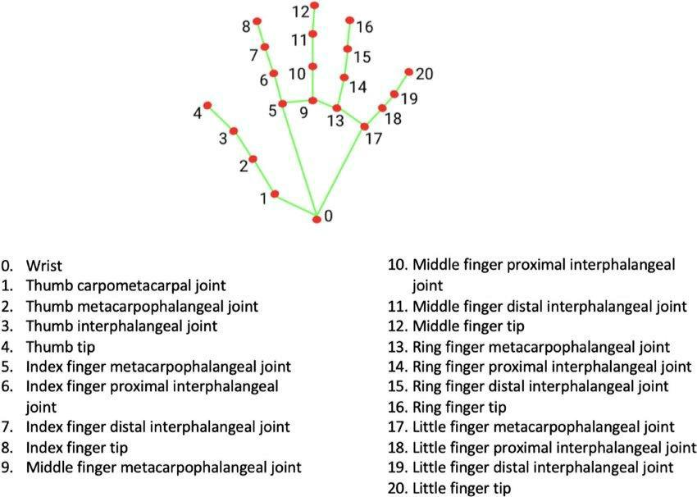

Fig 3.1 Hand Keypoints

3.2 Source and Methods of Collecting Data

Collected the dataset from github

GITHUB LINK: https://github.com/arpita739/ Sign-Language-Recognition-using-MediaPipe-and-Machine-Learning

5
Chapter 4

PREPROCESSING AND FEATURE SELECTION

4.1 Overview of Preprocessing Methods

Data preprocessing is a Data Mining approach that entails converting raw data into a format that can be understood. Data is frequently inadequate, inconsistent, and/or lacking in specific behaviours or trends, as well as including numerous inaccuracies. Real-world data typically contains noise, missing values, and is sometimes in an unsuitable format that cannot be used directly for machine learning models. Data preprocessing is a necessary step for cleaning data and preparing it for use by a machine learning model, which improves the model's accuracy and efficiency.

4.2 Overview of Feature Selection Methods

Each hand spotted will yield 21 landmarks, each of which is made up of x, y, and z coordinates. The picture width and height are used to normalise the x and y values between 0 and

- The landmark depth is represented by the z coordinate, with the origin at the wrist. Smaller z values also indicate that the landmark is nearer the camera. Drawing utils and hands are two classes that can be defined. Among other things, the drawing utils package offers some handy assistance functions for drawing detections and landmarks over images. utilise the Hands class from the hands module to detect hand landmarks on an image. We're doing this to save time by not having to remember the entire path every time we want to use one of these modules' features. The static image mode argument will be set to True as an input to the function Object() { [native code] } of this class, indicating that the photos it processes should be viewed as unrelated, implying that hand detection should be performed on each image. If this parameter is False, the images will be processed as a video stream, which means that after successfully detecting hands, it will localise the hand landmarks and then simply track them in subsequent photos.

6
It's vital to remember that the process method receives an RGB image, but when we read images using OpenCV, we get them in BGR format. As a result, we use the cv2 module's cvtColor function to convert our original image to RGB before passing the result to the process method. We only require the image in RGB format for the landmarks estimate procedure because the result will be displayed in an OpenCV window, which will display the image in BGR format correctly. The multi hand landmarks field of the NamedTupled we just retrieved contains the estimated landmarks for each identified hand. We'll go over each piece again and again, drawing the identified spots on the image. The landmarks for that detected hand will be contained in each element (so think of the multi hand landmarks as an array of arrays). The landmarks are then drawn using the drawing utils module's draw landmarks function. We pass the image where we wish to draw the landmarks as the first input. As second input we pass the list of hand landmarks of the hand.

7
Chapter 5

MODEL DEVELOPMENT

5.1 Model Architecture

The proposed system model architecture are shown in Fig: 5.1.
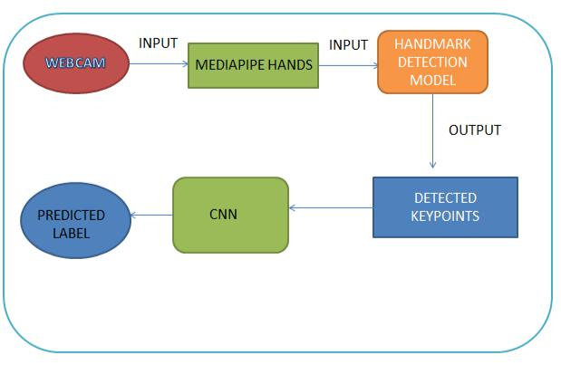

Fig: 5.1 Model Architecture

Webcam capture the sign and through mediapipe hands sign will be converted hand markdetetion model and detected the keypoints then using CNN it will predict the label of the sign.

8

5.2 Algorithms Applied

Convolutional neural networks are made to derive conclusions from visual input like images and videos.The features are extracted and learned to train the model, which gives better recognition accuracy compared to conventional Machine Learning algorithms. CNNs have numerous applications in the field of Signal Processing, robotics, medical imaging, data analysis, Business Intelligence, etc. Using CNNs to learn on a smaller, unaltered dataset produces surprisingly better outcomes.

The CNN architecture is made up of numerous layers, which are referred to as deep learning functional units. The architecture accepts input data and learns from it to determine the values of weights and biases using predefined hyperparameters. After each iteration of the learning process, the accuracy or loss is tested against a validation dataset, which is a portion of the original data set aside before training. The following are descriptions of the layers utilised in the experiments:

Dense Layer: The number of units given in the code has an impact on the dense layer's output shape.It is a regular NN layer that simply applies activation and gives output.

Dropout Layer: CNN architecture might undergo overfitting in which the model gets trained specifically to given training data and thus fails on any new data. Dropout is the solution to avoid overfitting in which involves the elimination of randomly selected nodes from each iteration learning process.

Relu: A Rectified Linear Unit(ReLU) is a non-linear activation function that performs on multi-layer neural networks.

Softmax: In the output layer of neural network models that predict a multinomial probability distribution, the softmax function is utilised as the activation function. That is, softmax is used as the activation function for multi-class classification problems where class membership is required on more than two class labels

9

5.3 Training Overview

In this proposed system split the data into training and testing through train_test_split function . here proposed system used 0.8 data is a training process and the remaining 0.2 data is testing process.

From sklearn.model_selection import train_test_split

In this system number of epochs will 500, optimizer as adam, batch size will be 128, loss will be sparse_categorical_crossentropy

10
Chapter 6

EXPERIMENTAL DESIGN AND EVALUATION

6.1 Experimental Design

We can develop the framework to implement the system in Python framework to classify the signs using deep learning algorithm. We can input train the datasets with different signs.

6.2 Experimental Results

In experimental results, from key features datasets, the sign facts are acquired which are employed to measure the usefulness of the suggested method. The system's performance is assessed using F-measure, Recall, and Precision.

Precision = |  | 6.1

Recall =

F measure = 2* |  | 6.2

The fraction of total number of predictions to total quantity of test data is known as accuracy (ACC).It can also be represented as 1 – ERR. The finest possible accuracy is 1.0, whereas the very worst is 0.0.

x 100 6.3

11
Table: 6.1 Classification Report

Calculating Classification report using equation 6.1, 6.2 and 6.3

LABEL | PRECISION | RECALL | F1-SCORE | SUPPORT
0 | 0.99 | 0.90 | 0.95 | 105
1 | 0.91 | 1.00 | 0.95 | 99
2 | 0.92 | 0.66 | 0.77 | 146
3 | 0.73 | 0.58 | 0.65 | 185
4 | 0.63 | 0.95 | 0.76 | 168
5 | 1.00 | 0.85 | 0.92 | 88
6 | 1.00 | 0.92 | 0.96 | 39
7 | 0.98 | 0.75 | 0.85 | 73
8 | 0.91 | 1.00 | 0.95 | 86
9 | 0.96 | 1.00 | 0.98 | 54
10 | 0.93 | 0.93 | 0.93 | 123
11 | 0.95 | 0.83 | 0.89 | 196
12 | 1.00 | 0.97 | 0.98 | 230
13 | 0.97 | 1.00 | 0.98 | 143
14 | 0.95 | 0.97 | 0.96 | 125
15 | 0.99 | 1.00 | 0.99 | 228
16 | 0.99 | 0.96 | 0.97 | 193
17 | 0.87 | 1.00 | 0.93 | 256
18 | 0.95 | 0.99 | 0.97 | 117
19 | 0.64 | 1.00 | 0.78 | 140
20 | 0.92 | 0.87 | 0.89 | 165
21 | 1.00 | 0.98 | 0.99 | 134
22 | 0.99 | 1.00 | 1.00 | 139
23 | 0.99 | 0.54 | 0.70 | 156
24 | 0.99 | 1.00 | 0.99 | 96
25 | 0.94 | 0.95 | 0.95 | 168
Accuracy |  | 0.90 | 3652
Macro Avg | 0.93 | 0.91 | 0.91 | 3652
Weighted Avg | 0.92 | 0.90 | 0.90 | 3652
 |  |  | 12

Using Table: 8.1 to create a model accuracy for train and test as show in Fig:6.2
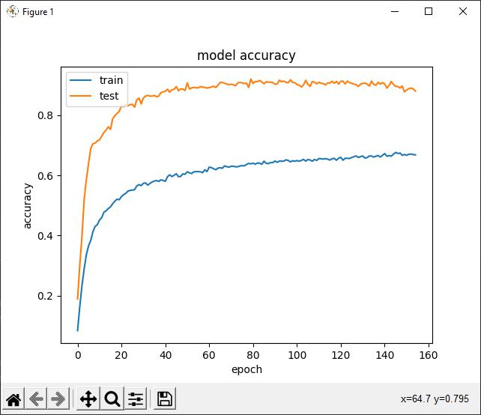

Fig: 6.2 Model Accuracy

A more important curve is the one with both training and tesing accuracy. Accuracy plot the gap between training and tesing accuracy is a clear indication of overfitting. The larger the gap, the higher the overfitting.

13
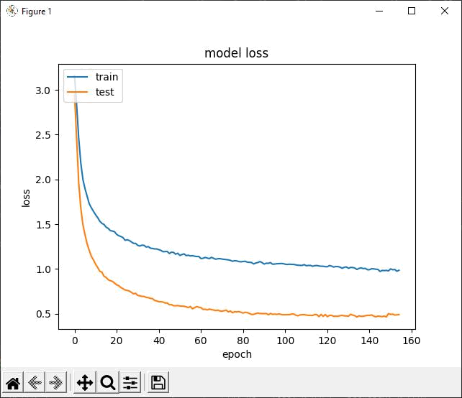

Fig: 6.3 Model loss

Loss measures our model error, or “how bad our model is doing”. So, for now, the lower our loss becomes, the better our model performance will be shown in Fig: 6.3.

14
Chapter 7

MODEL OPTIMIZATION

7.1 Overview of Model Tuning and Best Parameters Selection

KERAS SEQUENTIAL

For a simple stack of layers with one input tensor and one output tensor for each layer, a sequential method is best. It's helpful to incrementally stack layers using add() and print model summaries regularly when creating a new Sequential architecture. This allows you to see how a stack of Conv2D and MaxPooling2D layers is down sampling image feature maps, for example. Once developed, a Sequential model works similarly to a Functional API model. Every layer, thus, has an input and output attribute. These properties can be used to easily create a model that retrieves the outputs of all intermediate levels in a Sequential model

7.2 Model Tuning Process and Experiments

CNN is a form of neural network that can be used to recognise images.. It has other applications, but since it is only used for image processing by the MediaPipe framework, the following explanation will be focusing on that. An image, if it is not in grayscale, has two dimensions of the pixel and a third dimension of the color. CNNs are capable of processing information in one, two or three dimensions, coming from pixels that are near to one another. CNNs are composed of convolutional layers which connect neurons that only correspond to neighbouring pixels of the image. This reduces the amount of connections between neurons and therefore, reduces the number of weights to be processed.

- max_num_hands: Maximum number of hands to detect. Defaults to 2.

- min_detection_confidence: Hand detection must have a minimum confidence value (between 0 and 1) to be declared successful. The default is 0.5.

- min_tracking_confidence: hand detection must have a minimal confidence value (between 0 and 1). 0.5 is the default value.

15
Chapter 8

PRODUCT DELIVERY AND DEPLOYMENT

8.1 User Manuals

Need of the User manual

. Developers definitely deliver the product after developing the proposed system. The product user manual is required upon delivery. Because they are end users, users have no past familiarity with the product. If a problem arises while using this product, the user can quickly resolve it by consulting this user manual.

Information that provided in the User Manual

In user manual file have process of developing and deploying but importantly user manual have how to use this product like demo screens, how to handle the main file like how to train the hand gesture datasets because this product full and fully develop by deep learning with tensor flow and KERAS CNN so all machine cannot deep learning libraries that’s why application error can be occurred. Such an issues are same so developer can give solution through user manual.

In below What are the problem-solving options in that manual?

- Path error

- Version error

- CV2 error

Path error

In training phase, user can’t choose the files from correct path means, path error can be occurred

Version error

Need the version that satisfies the Mediapipe requirements

CV2 error

If the camera can’t connect to the system means, raise the CV2 error.

16
8.2 Delivery Schedule

Sign language recognition from camera using deep learning can be deployed and deliverable with in the given timeline of product delivery as shown in Table 8.1

Table: 8.1 Delivery Schedule

Date and No of Days | Which one is Deliver the customer
 | (user)
First week (3-4 days) | Project Proposal
Second week | Designing
Third week | User accept design then develop code
Fifth week | Styling changes in Design
Sixth week | Run in local server
Seventh week | Complete design and Processing
Tenth week | Deployment and solving user Problem
Final Stage | Product Delivery in Market

17
Chapter 9

CONCLUSION

9.1 Summary

Everyone can very persuasively transfer their thoughts and comprehend each other through speech. Our initiative intends to close the gap by including a low-cost computer into the communication chain, allowing sign language to be captured, recognised, and convert into text. This application is used to present a modern integrated planned system for hear impaired people. The camera-based zone of interest can aid in the user's data collection. Each action will be significant in its own right.

9.2 Limitations and Future Work

A model for ISL word and phrase recognition can be developed. This will necessitate the development of a system that can identify temporal changes.Create a complete product that will assist persons with speech and hearing impairments and thereby close the communication gap.

18
REFERENCES

- Naresh Kumar Sign Language Recognition for Hearing Impaired People based on Hands symbol Classification. International conference on computing, communication and Automation(ICCCA 2017)

- R.S.Sabeenian, S.Sai Bharathwaj,M.Mohamed Aadhil. Sign Language Recognition using Deep Learning and computer vision. Journel of adv research in Dynamical and Control Systems, vol 12,05-special Issue,2020

- Tulay Karayilan, Ozkan Kilic Sign Language Recognition 2nd International conference on computer Science and Engineering 2017

- Manisha.A, Neela Harish.M Thirekha.B.T, Kavya varshini.A.G Tamil Sign Language Recognition in real time IT in Industry,vol.9, No.2,2021 Published online 13-4-2021.

- Swaraj Dahibavkar , Jayesh Dhopte , Mahesh Patole , Sulochana Madachane.Marathi Sign Language Recognition. International Journal of Latest Technology in Engineering, Management & Applied Science (IJLTEMAS) Volume IX, Issue V, May 2020

- P.Subha Rajam, G.Balakrishnan Recognition of Tamil Sign Language Alphabet using Image Processing to aid Deaf-Dumb People. International Conference on Communication Technology and System Design 2018.

- Necati Cihan Camgoz, Oscar Koller, Richard Bowden al. Sign language transformers: Joint end-to-end sign language recognition and translation. Proceedings of the IEEE/CVF conference on computer vision and pattern recognition. March 2020.

- Ming Jin Cheok,Zaid ,Omar,Mohamed, Hisham jaward A review of hand gesture and sign language recognition techniques." International Journal of Machine Learning and Cybernetics 10.1 (2019): 131-153.published online 08 August 2017.

- Shruti Chavan, Xinrui Yu and Jafar Saniie Convolutional Neural Network Hand Gesture Recognition for American Sign Language.

19
APPENDIX-A

DATA SET

In this proposed system collect key point values for finger gestures with labels such as alphabetic letter.

Dataset
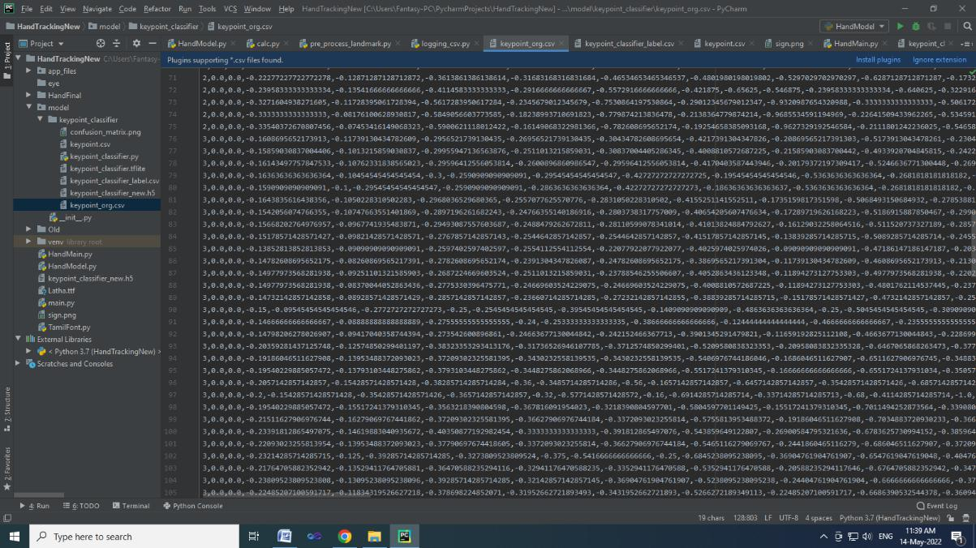

20
APPENDIX-B

SOURCE CODE

import csv

import copy

import cv2 as cv

import mediapipe as mp

from model import KeyPointClassifier

from app_files import calc_landmark_list, draw_info_text, draw_landmarks, get_args, pre_process_landmark

def main():

args = get_args()

cap_device = args.device

cap_width = args.width

cap_height = args.height

use_static_image_mode = args.use_static_image_mode

min_detection_confidence = args.min_detection_confidence min_tracking_confidence = args.min_tracking_confidence

cap = cv.VideoCapture(cap_device)

cap.set(cv.CAP_PROP_FRAME_WIDTH, cap_width)

cap.set(cv.CAP_PROP_FRAME_HEIGHT, cap_height)

mp_hands = mp.solutions.hands

hands = mp_hands.Hands(

static_image_mode=use_static_image_mode,

21
max_num_hands=1,

min_detection_confidence=min_detection_confidence, min_tracking_confidence=min_tracking_confidence,
)

keypointclassifier = KeyPointClassifier()

with open('model/keypoint_classifier/keypoint_classifier_label.csv', encoding='utf-8-sig') as f:

keypoint_classifier_labels = csv.reader(f)

keypoint_classifier_labels = [

row[0] for row in keypointclassifier_labels

]

while True:

key = cv.waitKey(10)

if key == 27: # ESC

break

ret, image = cap.read()

if not ret:

break

image = cv.flip(image, 1)

debug_image = copy.deepcopy(image)

- print(debug_image.shape)

- cv.imshow("debug_image",debug_image)

image = cv.cvtColor(image, cv.COLOR_BGR2RGB)

image.flags.writeable = False

results = hands.process(image)

image.flags.writeable = True

22
if results.multi_hand_landmarks is not None:

for hand_landmarks, handedness in zip(results.multi_hand_landmarks, results.multi_handedness):

landmark_list = calc_landmark_list(debug_image, hand_landmarks)

#print(hand_landmarks)

pre_processed_landmark_list = pre_process_landmark(landmark_list)

hand_sign_id = keypoint_classifier(pre_processed_landmark_list)

debug_image = draw_landmarks(debug_image, landmark_list)

debug_image = draw_info_text(

debug_image,

handedness,

keypoint_classifier_labels[hand_sign_id])

cv.imshow('Hand Gesture Recognition', debug_image)

cap.release()

cv.destroyAllWindows()

if __name__ == '__main__':

main()

import numpy as np

import tensorflow as tf

from sklearn.model_selection import train_test_split

23
RANDOM_SEED = 42

dataset = 'model/keypoint_classifier/keypoint.csv' model_save_path = 'keypoint_classifier_new.h5'

#all_null_values = dataset[dataset.iloc[:, 0] == 0] #print("Number of null values =", len(all_null_values.index))

dataset=dataset.drop(all_null_values.index, inplace=True)

NUM_CLASSES = 26

X_dataset = np.loadtxt(dataset, delimiter=',', dtype='float32', usecols=list(range(1, (21 * 2) + 1)))

y_dataset = np.loadtxt(dataset, delimiter=',', dtype='int32', usecols=(0))

print(len(X_dataset))

print(len(y_dataset))

print(y_dataset)

print(X_dataset.shape)

train_ratio = 0.80

test_ratio = 0.20

X_train, X_test, y_train, y_test = train_test_split(X_dataset, y_dataset, test_size=1-train_ratio, random_state=RANDOM_SEED)

model = tf.keras.models.Sequential([

tf.keras.layers.Input((21 * 2, )),

tf.keras.layers.Dropout(0.2),

24
tf.keras.layers.Dense(20, activation='relu'),

tf.keras.layers.Dropout(0.4),

tf.keras.layers.Dense(10, activation='relu'),

tf.keras.layers.Dense(NUM_CLASSES, activation='softmax')

])

model.compile(optimizer='adam',loss='sparse_categorical_crossentropy',metrics=['accuracy'])

cp_callback = tf.keras.callbacks.ModelCheckpoint(model_save_path, verbose=1, save_weights_only=False)

es_callback = tf.keras.callbacks.EarlyStopping(patience=20, verbose=1)

model.summary()

hist=model.fit(X_train,y_train,epochs=500,batch_size=128,validation_data=(X_test, y_test),callbacks=[cp_callback, es_callback])

import matplotlib.pyplot as plt

- val_loss, val_acc = model.evaluate(X_test, y_test, batch_size=128) scores = model.evaluate(X_test,y_test, verbose=0)

#print("CNN Error: %.2f%%" % (100 - scores[1] * 100)) model.save(model_save_path,include_optimizer=False) plt.plot(hist.history['accuracy']) plt.plot(hist.history['val_accuracy'])

plt.title('model accuracy') plt.ylabel('accuracy') plt.xlabel('epoch') plt.legend(['train', 'test'], loc='upper left') plt.show()

- summarize history for loss

plt.plot(hist.history['loss'])

25
plt.plot(hist.history['val_loss'])

plt.title('model loss')

plt.ylabel('loss')

plt.xlabel('epoch')

plt.legend(['train', 'test'], loc='upper left')

plt.show()

from keras.models import load_model

from sklearn.metrics import classification_report, confusion_matrix

import numpy as np

import time

import matplotlib.pyplot as plt

def plot_confusion_matrix(cm,

target_names,

title='Confusion matrix',

cmap=None,

normalize=True):

import itertools

accuracy = np.trace(cm) / float(np.sum(cm))

misclass = 1 - accuracy

if cmap is None:

cmap = plt.get_cmap('Blues')

plt.figure(figsize=(20, 20))

plt.imshow(cm, interpolation='nearest', cmap=cmap)

plt.title(title)

plt.colorbar()

26

if target_names is not None:

tick_marks = np.arange(len(target_names))

plt.xticks(tick_marks, target_names, rotation=45)

plt.yticks(tick_marks, target_names)

if normalize:

cm = cm.astype('float') / cm.sum(axis=1)[:, np.newaxis]

thresh = cm.max() / 1.5 if normalize else cm.max() / 2

for i, j in itertools.product(range(cm.shape[0]), range(cm.shape[1])):

if normalize:

plt.text(j, i, "{:0.4f}".format(cm[i, j]),

horizontalalignment="center",

color="white" if cm[i, j] > thresh else "black")

else:

plt.text(j, i, "{:,}".format(cm[i, j]),

horizontalalignment="center",

color="white" if cm[i, j] > thresh else "black")

plt.tight_layout()

plt.ylabel('True label')

plt.xlabel('Predicted label\naccuracy={:0.4f}; misclass={:0.4f}'.format(accuracy, misclass))

plt.savefig('model/keypoint_classifier/confusion_matrix.png')

model = load_model('model/keypoint_classifier/keypoint_classifier_new.h5') pred_labels=[]
start_time = time.time()

pred_probabs = model.predict(X_test)

end_time = time.time()

27
pred_time = end_time - start_time

avg_pred_time = pred_time / X_test.shape[0] print('Average prediction time: %fs' % (avg_pred_time))

for pred_probab in pred_probabs:

pred_labels.append(list(pred_probab).index(max(pred_probab)))

cm = confusion_matrix(y_test, np.array(pred_labels))

classification_report = classification_report(y_test, np.array(pred_labels))

print('\n\nClassification Report')

print('---------------------------')

print(classification_report)

plot_confusion_matrix(cm, range(26), normalize=False)

28
APPENDIX-C

OUTPUT SCREEN SHOTS
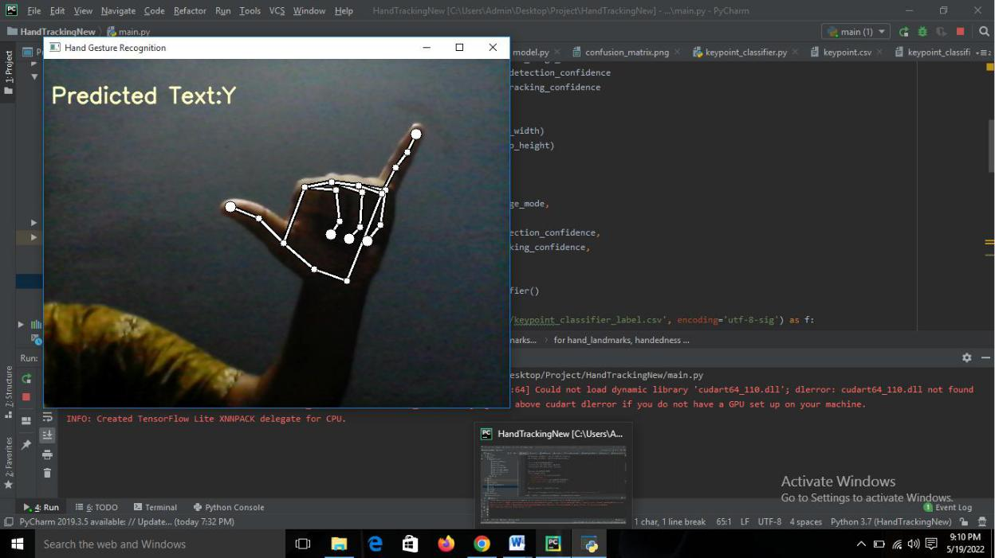

It will shows the sign of the alphabet Y in text
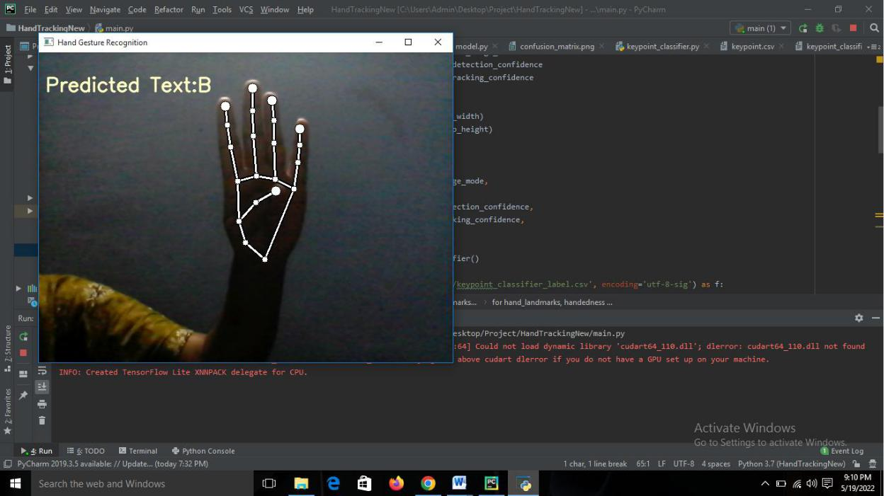

It will shows the sign of the alphabet B in text

29
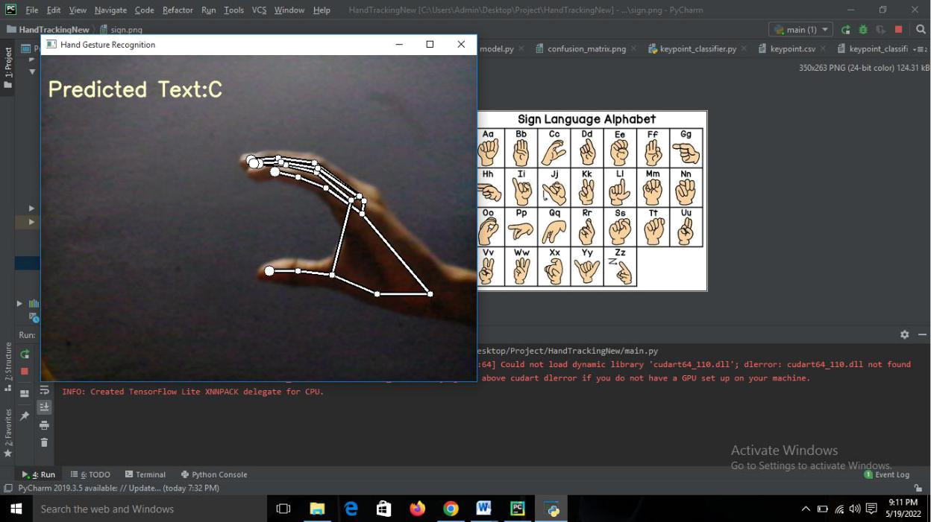

It will shows the sign of the alphabet C in text
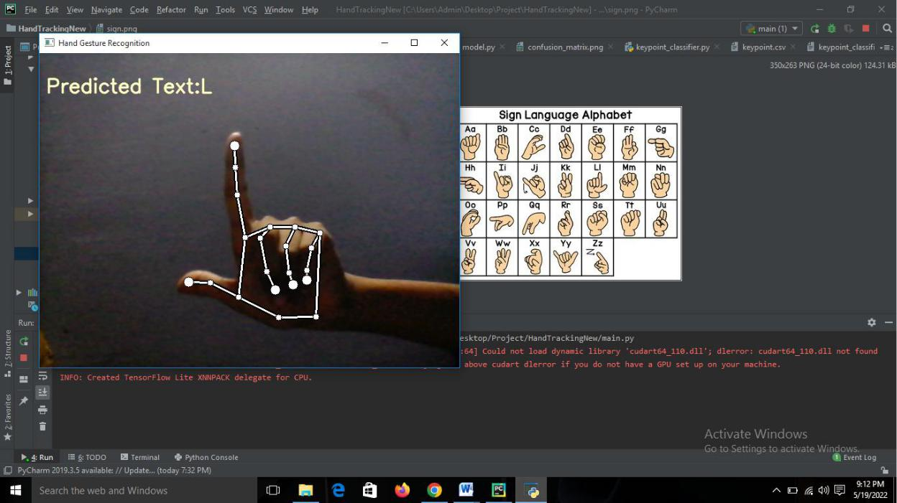

It will shows the sign of the alphabet L in text

30
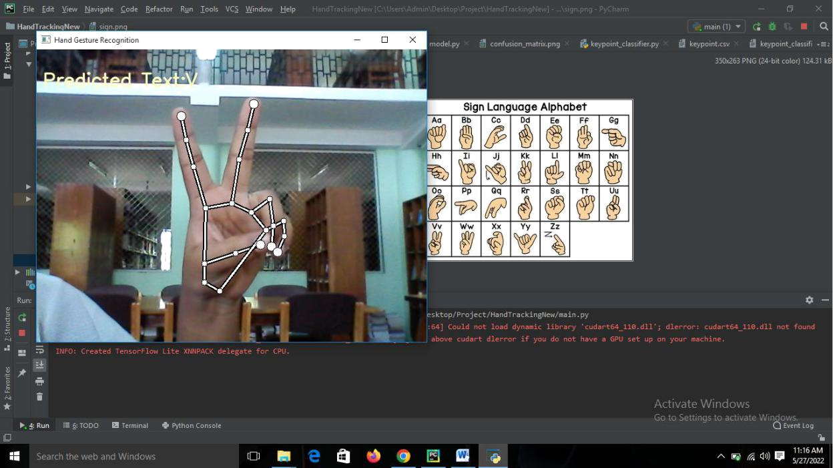

It will shows the sign of the alphabet v in text
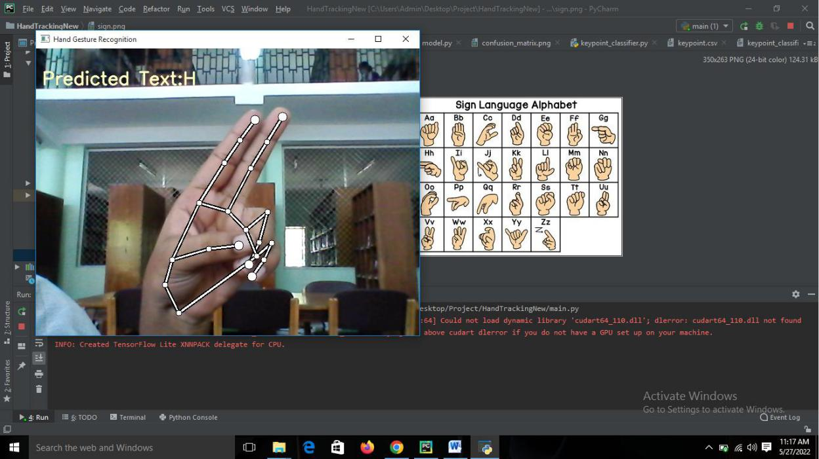

It will shows the sign of the alphabet H in text

31
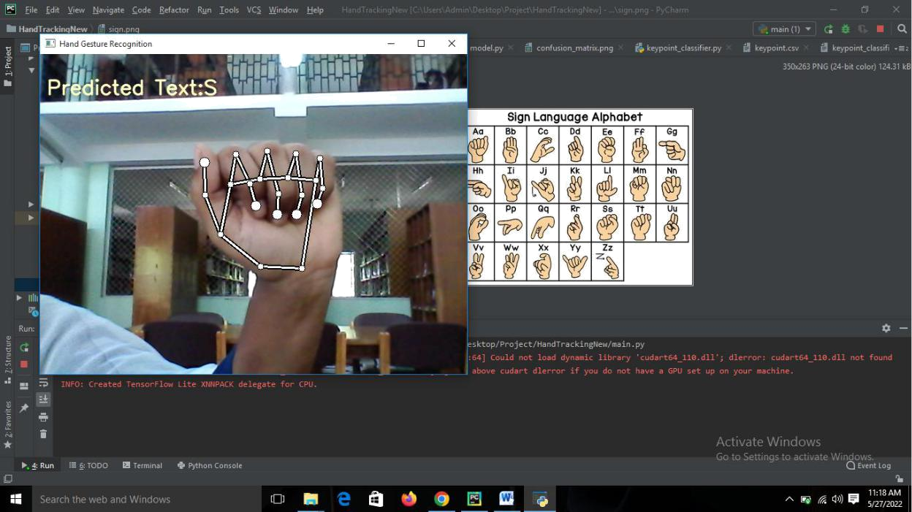

It will shows the sign of the alphabet S in text
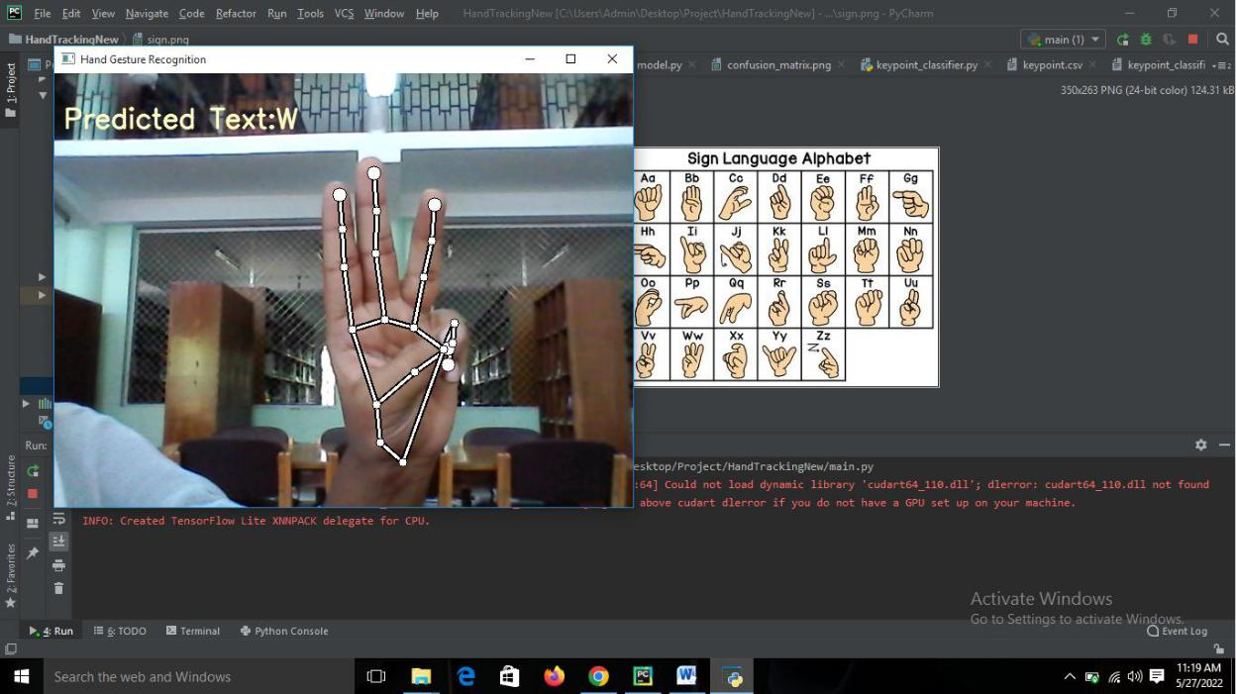

It will shows the sign of the alphabet W in text

32

